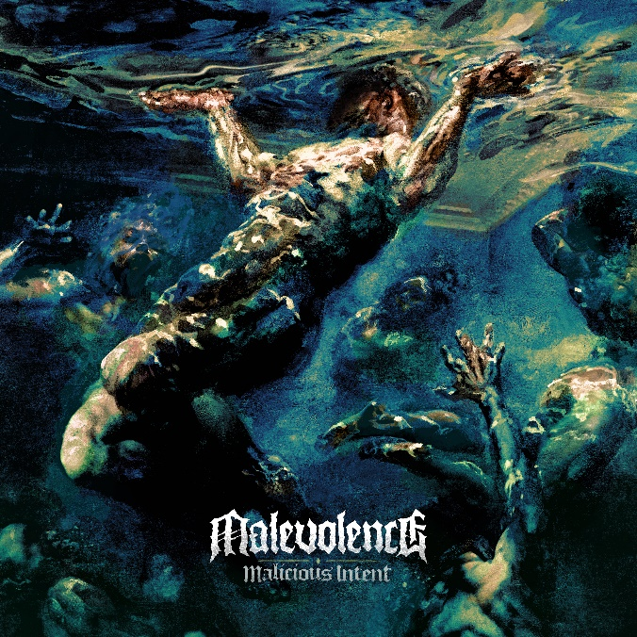

MALEVOLENCE

«Malicious Intent«

OUT: May 20th, 2022
Line up: | MALEVOLENCE online:
Alex Taylor | Vocals  Konan Hall | Guitar, Vocals  Josh Baines | Guitar  Wilkie Robinson | Bass  Charlie Thorpe | Drums | http://mlvltd.com  http://facebook.com/MLVLTD  http://twitter.com/MLVLTDMUSIC  http://instagram.com/m.l.v.l.t.d

“We wanted to write an album that encompasses our sound – but we wanted to push It further and go deeper,” says Malevolence frontman Alex Taylor. Indeed, with their third album, Malicious Intent, the Sheffield-born Malevolence has done just that. Ask anyone who has seen ‘em setting fire to tiny pressure-cooker hardcore gigs to igniting massive pits at big-stage metal festivals. Anyone who witnessed their set at Bloodstock 2021, knows that this is their reckoning hour. Malevolence has truly arrived. Formed in the north of England, Malevolence has perfected a sound of their own that swaggers like a band born in New-Fucking-Orleans while embracing the power of the riff and the brutality of the breakdown. “We made it a point to step outside our comfort zone,” says Taylor, “but also do what we started this band to do in the first place – play the metal that we want to hear.”
From the hard-as-Sheffield steel title track that opens the album, Malevolence has upped their own ante. To paraphrase one of their biggest influences, Pantera, it’s the sound of a band on a “New Level”. You can spot the influences – those unforgettable wrecking ball riffs rooted in the hate-sludge of Crowbar, the guitar finesse of Dimebag Darrell and the all-out catchiness and brutality of Hatebreed, Malevolence has asserted their status not merely as a contender, but as force to be reckoned with.
It's not all bluster and brutality. While the likes of ‘Life Sentence‘ hits like a ten-ton baseball bat, ‘Higher Place‘ is a surprisingly plaintive, almost ballad-esque moment where guitarist Konan Hall seamlessly blends his voice with the normally gruff Taylor. “If you’re a Malevolence fan, you know to expect the hard, fast and aggressive but then there’s a completely different side that’s heartfelt, moving sound that is there for self-reflection,” explains the vocalist. “When you combine them, that’s where we’re at with this album. I get asked a lot whether I consider us a hardcore band or a metal band or a metalcore band. To me, it’s just heavy metal. It’s simply us, Malevolence.”
The bloody roots of Malevolence stretch back to 2010 when childhood friends, guitarists Josh Baines and Hall, who had been playing together since 2005 joined up with bassist Wilkie Robinson and drummer Charlie Thorpe, and recorded the first proper Malevolence demo with Taylor on vocals. Fueled on a steady diet of Roadrunner Records samplers and Road Rage tours, the seeds for Malevolence were planted. “Seeing Chimaira and Killswitch Engage were some of my earliest metal concerts,” says Alex, “and they’re some of my favourite bands to this day. The kind of diversity those bands brought to the table inspired us to do what we do. They never limited themselves to one sound.” In 2013, Malevolence burst upon the worldwide stage with the release of the debut album Reign of Suffering on Siege of Amida/Century Media, touring Europe with Dying Fetus and then charging through America with Kublai Khan and Jesus Piece.
“Realising that our music could take us to take us to other countries and seeing the praise the first album had gotten took us completely by surprise,” recalls Alex. “We went to the US and had incredible shows at places like Chain Reaction [Anaheim,California]. Then, in 2019, touring for our second album, Self Supremacy, we went to Asia for the first time. We had experiences that completely changed my whole perspective. Going to places like the Philippines and playing for kids who had very little but saved for months and months just to see us play! And then, they took us out for food, took us swimming with whale sharks. It was completely humbling. And inspiring. Screaming has taken me to the other side of the word – and I’m so grateful for that.”
With a clutch of plaudits for their self-released 2020 3-track EP, The Other Side, which featured Knocked Loose vocalist Bryan Garris on the track, ‘Keep Your Distance‘, Malevolence set to the business of writing and recording Malicious Intent – in the shadow of COVID and a worldwide lockdown. Amidst a flurry of praise including a prophetic review from Kerrang!: “Brace for impact when their full-length finally hits.” The fivesome turned isolation into focus.
“As soon as we realised that things weren’t going to get better, that the pandemic was going to be an upheaval of our daily lives, we threw ourselves into it,” recounts Alex. “We found a warehouse space in Sheffield that we spent hundreds and hundreds of hours converting. It became our writing and rehearsal space – but I actually recorded my vocals for the album there. While it felt like the world may have turned to shit, we pushed ourselves to stay positive and that definitely came out on the album.” The results, produced and mixed by Jim Pinder and Carl Bown at Treehouse Studios in Derbyshire, UK (Bullet For My Valentine, Bring Me The Horizon) speak for themselves.
“Malicious Intent is the sound of Malevolence being utterly true to ourselves,” the vocalist states. “The song ‘Salvation’, which features Matt Heafy from Trivium is the probably the most honest I’ve been on a song lyrically. It deals with mental health. I knew I wanted to push myself and be open and then having Matt coming to the fray wanting to be on a song was a massive thing for me. Trivium’s Ascendency was one of the first heavy albums I had ever listened to! 13-year-old me was blown away!”
It's clear – Malevolence is set to explode in 2022. Already distinguishing themselves as a force to be reckoned with in an exploding UK metal scene, they’ve stepped to the front of the class with force and finesse. Their intent has never been so completely realized.

